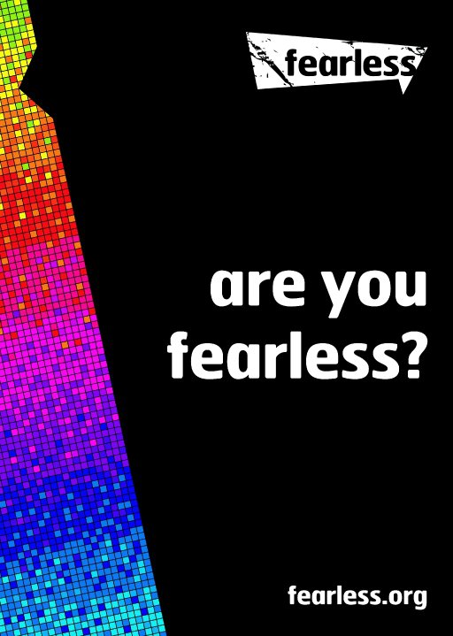
July 21st 2016-17 Fearless from knife crime
Fearless from Knife Crime
The ‘Fearless from Knife Crime’ session was created following the 28% increase in the possession of weapons within Gloucestershire for 2015. The project was aimed at addressing the problem of knife crime in the medium and long term in Gloucestershire by engaging, informing and educating young people in Year 8 (12-13 year olds) about the risks and consequences of knife crime activities whilst promoting local services available to them (including the anonymous reporting service available on fearless.org)

- Fearless is a youth brand of the independent national charity Crimestoppers. Fearless encourages young people to make positive, informed decisions around crime and criminality. Uniquely, young people can also pass on information anonymously about crime to Fearless.org. This empowers young people to have a voice in their community to help prevent crime, if for whatever reason they feel they cannot engage with the police.

Not only do these sessions have an impact on increasing young people’s confidence in reporting crime, they also count towards achieving one of the two credits needed for a Healthy Schools Certificate and are located in the PSHE PINK handbook.
We have successfully delivered this year’s work with some excellent feedback and statistics below.
Working with Schools
During the year 2016/17 we have worked with 15 schools across Gloucestershire delivering interactive and informative sessions with secondary schools students.
- 3422 Young People Reached - Schools visited - 15
- 151 workshops delivered
An increase in confidence and awareness
We conducted questionnaires with participants before and after our sessions..mmkkk

Responses showed clearly an improvement in awareness and confidence around the issue of knife crime.

Feedback from the sessions

From my perspective I think the students found you both engaging and approachable and got a lot from the sessions. I was particularly impressed by your ability to roll with the various IT challenges and your confident, relaxed manner with the kids was excellent. Very few people manage to come in and speak to a class with such an assured confidence.
We'd certainly be keen to repeat the exercise next year if your funding allows.”
Barry Hockaday, Subject Leader – Futures, Severn Vale
“Newent Community School and Sixth Form Centre have been extremely fortunate to have had Fearless in school working with our students on dangers of carrying weapons. I have observed many of the sessions, all of which have had a massive impact on our students. Leon has worked with year 8 and year 11 students.
Leon shares his story of being a victim to knife crime – alongside the story of Joe – who was in prison for violent attack – who joined Leon for the second session.
From the start of each session, Leon strikes a rapport with the young people, interacting with the students, using role pay and plenty of discussion to help them understand all the key messages.
They were shown a short CCTV video of a knife crime incident which again, helped to show how dangerous the smallest of knife wound can be.
Students go away from the session with many very important learning points – how the choice to carry a weapon can have a catastrophic impact on yours and other life. How crime impacts on so many people, the ripple effect, and how violence is not a solution to any problem.
We would most certainly recommend all young people have this session. “ Di Harrill
Learning Lead PSHE

Crypt school feedback
‘The first of the two sessions enabled the students to understand what knife crime is all about and they began to understand that knife crime happens in and around the local area. The second session was the better of the two as Leon and Joe told their own personal stories about incidents which had happened. The pupils loved the storytelling aspect of the session, they were able to understand that knife crime is a reality and the damages that the 'ripple effect' can have on both family and friends. Joe's story came as a shock to both the students and myself, being that he is a criminal and is currently serving his sentence. However, I feel that Joe's story, although not directly related to knife crime got the students thinking about how one bad decision can affect the rest of your life. Both stories were powerful and engaged the students very quickly. Both myself and the students became very intrigued about not only which crimes can get you into prison but prison life in the United Kingdom. Introducing the students to real criminals and allowing them to ask questions was a really important part of the second session. All students got involved and enjoyed the sessions. Overall, a very informative and engaging workshop’
Teacher feedback

Youth project feedback
The workshop was very informative and thought provoking. The content was well balanced and perfect for the target group of young people. I know the young people really engaged well with your talk and the videos brought home the message to them. the content was just right and for the right amount of time, you must of done well as they kept asking you more questions when you finished.
You interacted really well with the group and kept it light hearted, fun but still managed to get the serious nature of this issue across as well. I thought you did a great job at presenting your workshop to our group.
Project lead James Alderidge from Green Square housing

Testimonials
We evaluate our work through qualitative and quantitative evaluations with young people. Young people were asked by us how they evaluated our sessions.
I think that Leon coming in the school to talk to us was good because it made us all more aware of knife crime and fearless and what they do. I also thought it was good how someone who had experienced the consequences that come with criminal actions spoke to us because we then take more notice if it’s being told by the actual person rather than someone with no experience just telling us a story.
I think you should do this in other schools so people know the consequences of using or having a knife.
I have now realised that I don't have to be afraid to tell someone if I know of someone carrying a knife
I enjoyed this session and it has made me feel more aware that there is the possibility of someone carrying a knife around me, but without scaring me.... I have kept the 'Fearless' card and it is easily accessible if I ever need to know who to contact. Thank you very much for teaching us about knife crime
I thought that it shaped up my awareness of knife crime because I didn't really know anything about the consequences of knife crime before the session.
Great, should do every year and maybe different crimes- learned a lot
I liked the lesson because it gives you a chance to learn how to be safe.
I thought that it shaped up my awareness of knife crime because I didn't really know anything about the consequences of knife crime before the session.

Fearless increases the impact of the sessions for young people by including real life stories that young people can relate to and see first-hand the consequences that their actions could have from the mentors resulting in life changing sessions.

Working in Partnership
To increase impact the Fearless project has built up strong partnerships with local stakeholders often running joint events and workshops. The partners we have worked with this year include:

